# GOLDEN RICE

***A project report submitted to MALLA REDDY UNIVERSITY***

***in partial fulfillment of the requirements for the award of degree of***

**BACHELOR OF TECHNOLGY**

**in**

## COMPUTER SCIENCE & ENGINEERING (AI & ML)

**Submitted by**

**SHIVAM KUMAR JHA : 2011CS020353**

**SHAIK YASAR : 2011CS020354**

**SYED MINHAJ : 2011CS020355**

**T.ABHINAV BRAHMA : 2011CS020356**

***Under the Guidance of***

**Prof . A.UDAYA LAKSHMI**

**DEPARTMENT OF COMPUTER SCIENCE & ENGINEERING (AI & ML)**

2023



**COLLEGE CERTIFICATE**

This is to certify that this is the bonafide record of the application development entitled, “**GOLDEN RICE**” Submitted by Shivam Kumar Jha (2011CS020354), Shaik Yasar (2011CS020354), Syed Minhaj (2011CS020355), T.Abhinav Brahma (2011CS020356) B. Tech III year I semester, Department of CSE (AI&ML) during the year 2022-23. The results embodied in the report have not been submitted to any other university or institute for the award of any degree or diploma.

**INTERNAL GUIDE HEAD OF THE DEPARTMENT**

**Prof . A.Udaya Lakshmi**

## Dr. Thayyaba Khatoon CSE(AI&ML)

|  |  |  |  |  |
| --- | --- | --- | --- | --- |
| **CHAPTER NO.** | 1. | **TITLE**  INTRODUCTION: | **CONTENTS** | **PAGE NO.** |
|  |  | 1.1 | Problem definition | 1 |
|  |  | 1.2 | Objective of project | 1 |
|  | 2. | 1.3  ANALYSIS: | Limitations of project | 1 |
|  |  | 2.1 | Introduction | 2 |
|  |  | 2.2 | Software requirement specification | 3 |
|  |  |  | 2.2.1 Software requirement | 3 |
|  |  |  | 2.2.2 Hardware requirement | 3 |
|  |  | 2.3 | Existing System | 3 |
|  |  | 2.4 | Proposed Systems | 3 |
|  |  | 2.5 | Modules | 3 |
|  |  | 2.6 | Architecture | 4 |

**ABSTRACT**

As we know the fact that, India is the second largest populated country in the world and majority of people in India have agriculture as their occupation. Farmers are growing same crops repeatedly without trying new verity of crops and they are applying fertilizers in random quantity without knowing the deficient content and quantity. So, this is directly affecting on crop yield and also causes the soil acidification and damages the top layer. So, we have designed the system using machine learning algorithms for betterment of farmers. Our system will suggest the best suitable crop for particular land based on content and weather parameters. And also, the system provides information about the required content and quantity of fertilizers, required seeds for cultivation. Hence by utilizing our system farmers can cultivate a new variety of crop, may increase in profit margin and can avoid soil pollution.

* 1. **Problem Definition**

# CHAPTER - 1

## 1 . INTRODUCTION

“**Crop prediction using machine learning**” predicts the best crop growth for particular season based on required parameters like, required nutrients for crop, required seed for cultivation, approximated yield, market price of crop and providing the results to the farmers and market Analysis for better crop growth.

## Objective of project

The Objective of our study is to provide a solution for smart agriculture by monitoring the agricultural field which can assist the farmers in increasing productivity to a great extent.

## Limitations

A risk and a negative outcome of price forecasting is the possible distortion of market prices. If all the farmers who receive the forecasts decide to sell at one particular market, this could lead to over-supply and subsequently lower prices with long waiting period for the farmers to sell their produce. Contingencies for such an outcome needs to be planned while preparing for deployment in real world.

# CHAPTER - 2

## 2 . ANALYSIS

* 1. **Introduction**

Agriculture produce is subjected to various risks, which are not only confined to production risk pertaining to weather, pest but also the demand and supply of various countries, other policy and economic factors. With restricted knowledge to understand and comprehend the information, farmers can incur huge losses by selling their produce in distress. Farmers no longer have to contend with just local markets. They also have to account for competition from the world over. High price volatility has been a major concern in past few years both for farmers and consumers. Higher price volatility has driven the search for reliable and accurate price forecasting techniques for agricultural commodities. The main purpose of price prediction is to help producers manage their price risk and take informed decisions. Machine Learning has proved to be better than the traditional time series method of price prediction, using many linear and non-linear forecasting models. Machine Learning based price prediction provides a unique way of combining technical and fundamental analysis methods. While technical analysis solely looks at historical price, fundamental analysis consists of understanding external and internal factors that influence the prices of a certain commodity. Individually technical analysis can be useful for providing accurate short-term prediction while fundamental analysis can help in long term forecast. By combining the two, higher accuracy in predictions can be achieved.

## Software Requirement Specification

* + 1. **Software Requirement**

Jupyter Notebook

Libraries like NumPy, Pandas, Matplotlib & scikit learn

## Hardware Requirement

No specific hardware requirements are needed, any PC having a python IDE can run this model

## Existing System

The existing survey studies did not systematically review the literature, and most of them reviewed studies on a specific aspect of crop yield prediction. Also, we presented 30 deep learning-based studies in this article and discussed which deep learning algorithms have been used in these studies.

## Proposed Systems

Our proposed system is a Web application which predicts name of the crop as well as calculate its corresponding yield. Name of the crop is determined by several features like temperature, humidity, wind-speed, rainfall etc. and yield is determined by the area and production. In this project, Random Forest classifier is used for prediction. It will attain the crop prediction with best accurate values.

## Architecture

After designing the working principle, the flow chart of the system is implemented where the code and the model is developed and tested. The flowchart of the complete system is shown in Fig. 2.6.

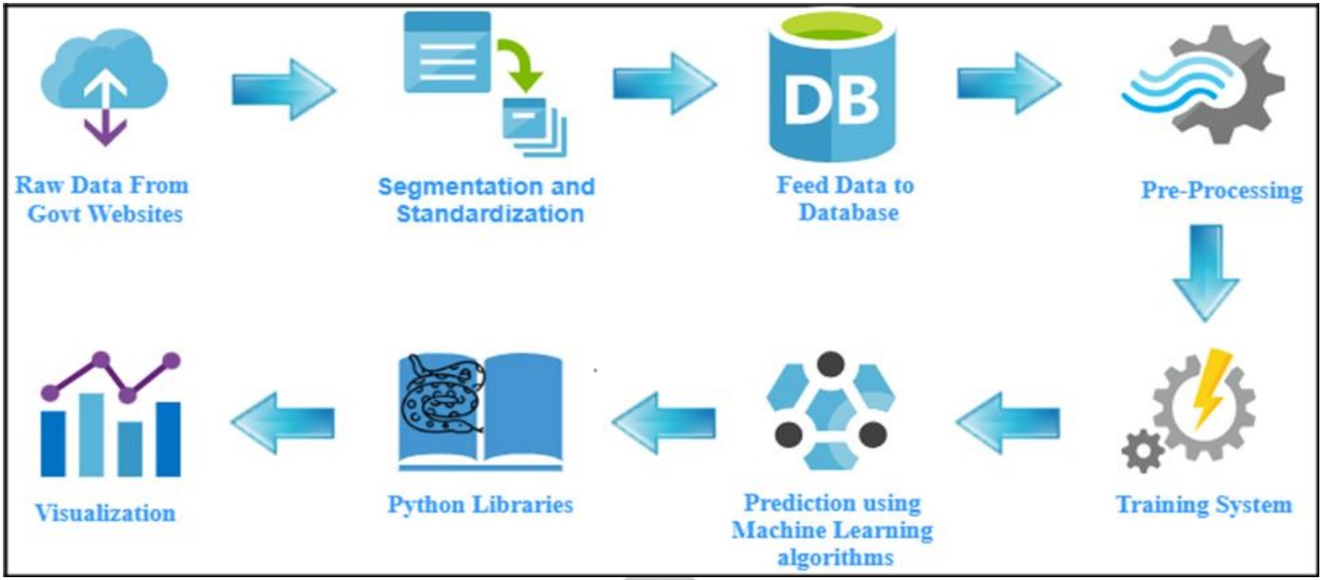

Fig 2.6